1. Click on Admintration -> Integrations -> Outgoing Webhooks

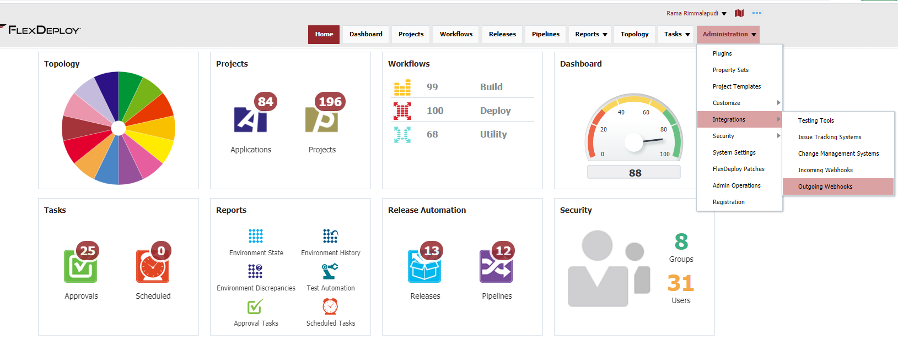

1. Click on Create Listener

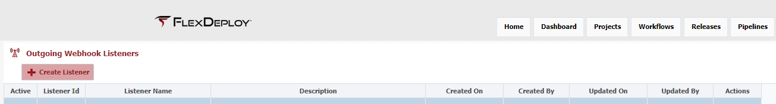

1. On this page enter following and click save.
   1. Listener Name as SaveExecutionLogs
   2. Select Workflow Completed checkbox
   3. On the filter enter following test

return EVENT.payload.project.projectName.contains('Code Scanner');

* 1. On the [**Script**](http://fdtlt07.flexagon:8000/flexdeploy/faces/outgoingwebhooks) tab replace the code with below code. Change the highlighted folder.

import flexagon.ff.adfext.common.model.pojos.communication.EmailAttachment;

import groovy.json.JsonOutput;

//Carry out any custom action you wish for this event. Check out the documentation for reference or ideas.

//Optionally filter out events you dont want to execute by returning false on the filter script tab.

def listenerName = "Email Failed Logs";

LOG.info("Running listener: ${listenerName}");

//retrieve plugin log input stream map

def logs = FLEXDEPLOY.getPluginLogInputStreams(EVENT.payload.workflowExecutionId);

logs.each { log ->

filename = "/tmp/logs/${log.key}.txt";

File file = new File(filename);

file.write(log.value.getText());

}

